Requirements Definition

Auction Application

1. **Introduction and Context**

The Auction Application aims to build a system for running an auction at a school or church activity. Current auction practices require lots of items, papers, and files to maintain. Our application will eliminate the need for paper and files and allow users to bid on items, view items, view winnings, etc. all from their mobile devices.

The auction system will support two auction types: live and silent. Live auctions will allow all users to see all the upcoming items. They will be able to bid in person like a regular live auction, but have all the information available on their device. The auctioneer admin will input the winner and ending price into the system after each sold item. The silent auction will be similar to online bidding websites. Users can log in, see all available items, the current item price, and item info.

Throughout the auction, users will have an overview of both live and silent auction winnings and what they owe. Admins will collect payments in person and be able to mark off the payment as accepted on their device.

Admins will be able to create the auction beforehand, view the current auctions, and have access to reports created from every auction.

1. **Users and their Goals**

The Users of this system will be those who attend the auction event. The goal for them will be to view the Silent and Live Auction items, bid on the Silent Auction items, and view their financial summary from bids and won items.

The Admins of this system will be those “running” the auction. The goal for them will be to create and manage the auctions, view a report of the auction, and receive payments.

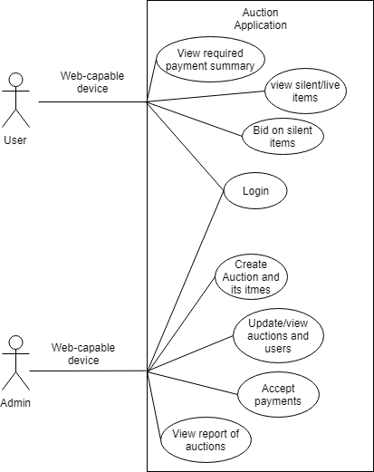

For more information concerning users, admins, their goals, and other information please see the Use Case diagram files in the Git repository.

1. **Functional Requirements**

*This section contains requirements or constraints on the functioning of the proposed system, written in way that doesn’t pre-suppose “how” the system will accomplish those requirements. The requirements should be organized in hierarchy of increasing specificity and presented in outline form so they are easy to reference. Each requirement must stand on its own because it could be referenced or quoted in other documents without the benefit contextual information. Where appropriate, the requirements could include statements about of the rationale (motivation) and/or priority (importance to the client.)*

3.1 Allow users to:

1. In the portal page:
   1. view general information and rules about the auction
   2. register and login to the auction
   3. view upcoming Silent and Live Auctions
   4. view current total bids
   5. view items won and total cost
   6. view payment status on items won
2. In the live auction page:
   1. view current item details
   2. view the queue of items
3. In the silent auction page:
   1. view the list of all items
   2. view the description for each each item
   3. view the current bid for each item
   4. place a bid on items that have not expired
   5. view their total current bid and winning amounts
   6. view how much time is remaining for individual items or the silent auction

3.2 Allow admins to:

1. In the portal page:
   1. be able to login
   2. see links to other pages
   3. create/update/publish/delete an auction
   4. add/update/delete items in an auction
   5. add/register offline users
2. in the payment page:
   1. see list of users and what they
   2. mark of payments as completed
3. in the reporting page:
   1. list of users with the following info
      1. items they’ve bought
      2. how much they spent
      3. auctions participated in
   2. total amount of money earned
4. in the live auction page:
   1. begin and end the auction
   2. see current item full details
   3. see queue of items
   4. close the current item and start the next item
      1. enter in who won the item by id
      2. enter what the ending price was
5. in the silent auction page:
   1. begin and end the auction
   2. see full-info about each item
6. **Non-functional Requirements**

4.1 The development of the application will follow an Agile method with weekly iteration meetings.

4.2 During the planning and development of the application, the team will meet at least two times per week.

4.3 The planning and development process will follow a Scrum method.

4.4 The application will be able to support 300 Users simultaneously

4.5 The application needs to be platform independent.

4.6 The application needs to be in in real-time. Bidders need instant feedback.

1. **Future Features**

5.1 As a User, I want to be able to flag Live Auction items and receive notifications when they will be auctioned next.

5.2 As a User, I want to be able to donate a dollar amount to specific classrooms or groups.

5.3 As an Admin, I want to divide the Silent Auction items into categories.

5.4 As an Admin, I want to be able to see what users are logged in.

5.5 As an Admin, I want to have a dashboard to see general statistics for the auction.

**Glossary**

*User/Bidder: specifically non-admin users*

*LIve Auction: bidders will bid on items in person. There will be an auctioneer*

*Silent Auction: bidders will bid on items online. Items may or may not be on display in person*

*live item/silent item: anything being sold in their respective auctions.*

*SCRUM/agile: defined set of procedures and best practices while developing software.*